**Assignment 23.1**

**Create a database named 'custom'. Create a table named temperature_data inside custom having below fields:**

1. **date (mm-ddyyyy) format**
2. **zip code**
3. **Temperature**

**Step1: Database creation.**

**Custom data base created.**

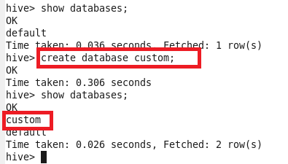

**Creating table:**

Here External Table is created with the name temperature_data with date ,zip_code,temperature as fields with if not exist option which fetches the data from /hive/dataset in hdfs and the data is stored as Textfile and as the input data is delimited by comma row format delimiter is “,”.

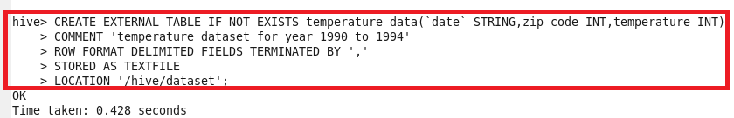

**Output:**

We can see that the temperature_data table is created in custom directory.

